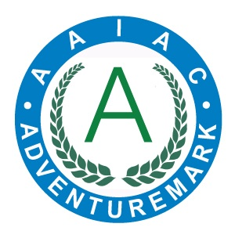
ADVENTUREMARK
www.adventuremark.co.uk
THORPE WOODLANDS ADVENTURE CENTRE
Has met the necessary standards for the safe delivery of
adventure activities as defined by the
Adventure Activities Industry Advisory Committee.

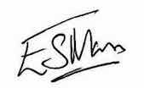
Elspeth Mason, Chair (AAIAC)

Abseiling | Jacobs Ladder
Archery | Kayaking
Artificial Climbing Wall | Leap of Faith
Artificial Climbing Wall | Low Ropes Courses
Canoeing | Mountain Biking
Caving – Artificial | Orienteering
Crate Stacking | Sit on Top Kayaking
High Ropes Courses | Team Building
Improvised Rafting | Zip Wires

Date Issued : 25th May 2025 Expiry Date : 25th May 2027

Certificate No : AAA101246

